- UK mortgage approvals fell for the first time in seven months in April, with the increase in mortgage interest rates since the turn of the year increasingly weighing on demand. Though the housing market has escaped a major price correction, valuations remain stretched and a period of relative stability for activity and prices looks more likely than a strong recovery.
- The long-term outlook for mortgage rates will be heavily influenced by where Bank Rate could settle when the Monetary Policy Committee's upcoming rate-cutting cycle ends. Our new estimate of the neutral interest rate suggests strong structural forces will drag on the policy rate, but that a return to the cheap mortgage deals preceding the pandemic is unlikely.
The health of the housing market and consumer lending were the main themes of a week very light on economic releases. Mortgage rates have been on a rollercoaster ride over the past couple of years. As thoughts turned towards the rate cutting cycle in late-2023, rates came down sharply. But since the turn of the year, market pricing has moved in a more hawkish direction, and lenders have reflected the increase in their funding costs by pushing up quoted mortgage rates.
This week's Bank of England Money and Credit release provided further evidence that the increase in mortgage rates is increasingly weighing on demand. Approvals for new home purchases fell fractionally to 61,140 in April from 61,263 in March, the first m/m decline in seven months (Chart 1). By contrast, net mortgage lending rose to £2.4bn in April from £0.5bn a month earlier, although this was largely because repayments dropped back from March's very high level. Meanwhile, Nationwide reported that prices rose 0.4% m/m in May, after a similar fall in April.
The housing market has escaped the major price correction that looked possible last summer. But a period of stability for activity and prices looks more likely than a strong recovery given that valuations remain very stretched. Mortgage rates should be supportive of a stable outlook – though swap rates have been very volatile, the two- and five-year rates are currently around the same levels they were a month ago, suggesting quoted mortgage rates should stay steady in the near-term.
Chart 1: Higher mortgage rates halted the recovery in mortgage demand in April
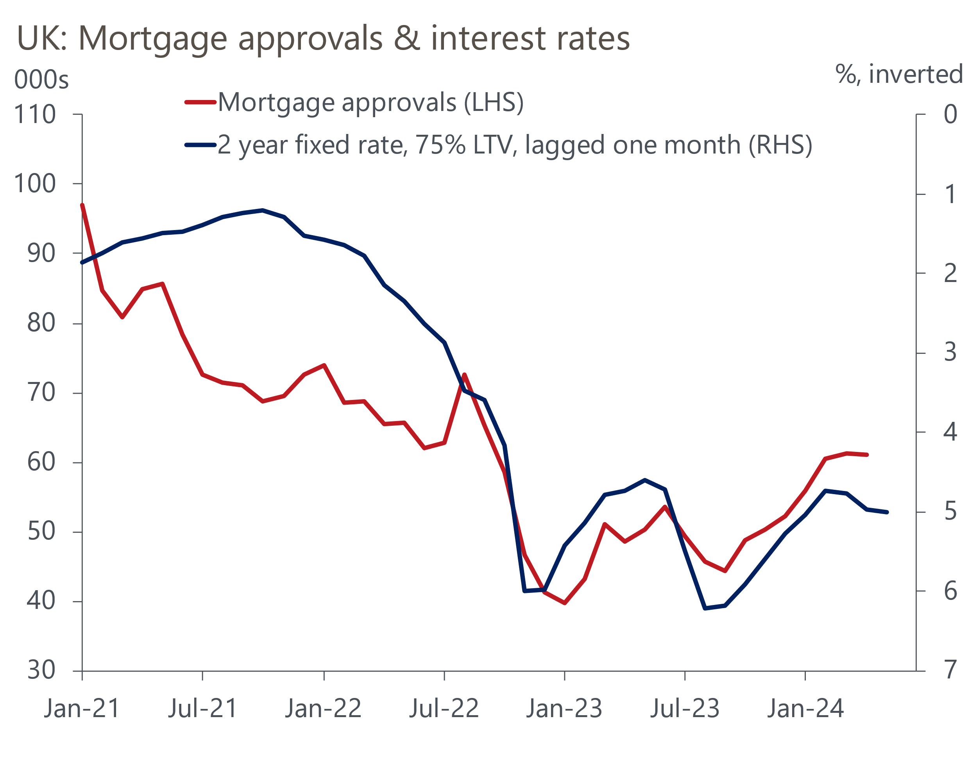
Source: Haver Analytics

The BoE release also reported a sharp drop in net unsecured lending to £0.7bn in April from £1.4bn in March, as a slump in gross lending more than offset a decline in repayments. These developments were consistent with the sharp fall in retail sales that month. But we expect that weakness to prove short-lived, as with wages now growing much more quickly than prices, real household incomes should continue to strengthen. Meanwhile, improving consumer confidence should translate into stronger demand for unsecured lending in the future.
The long-term outlook for mortgage rates will be heavily influenced by where Bank Rate might settle when the Monetary Policy Committee's upcoming rate-cutting cycle ends. To help inform our long-run view of the path for interest rates, we recently undertook some work to estimate the UK's neutral interest rate – the rate where monetary policy is neither stimulatory nor restrictive.
Subscribers to our Global Macro Service can access the full Research Briefing here. But the headline finding was that higher inflation expectations have lifted the nominal neutral rate in recent years, which we estimate is now around the 3% mark. Given Bank Rate is currently at 5.25%, this suggests the BoE's policy stance is quite restrictive at the moment, which is consistent with the language used in the MPC's recent policy statements and the slowdown in housing activity and mortgage demand we've seen since the MPC began its rate hiking cycle in late-2021.
Looking ahead, as inflation expectations continue to normalise, we think the structural forces that drove interest rates down in previous decades will increasingly reassert themselves. Indeed, our results suggest that the long-run nominal neutral rate may reach 2% by the end of this decade (Chart 2). Two main structural factors are likely to prevent a return to the much higher interest rates experienced in the decades preceding the global financial crisis. First, the UK's demographic outlook is weak, with improvements in longevity likely to continue to outpace increases in the retirement age. And second, though we expect the UK's productivity performance to improve a little, a return to pre-global financial crisis rates of productivity growth looks unlikely.
Chart 2: Our long-run neutral rate estimates suggest Bank Rate may end the decade around 2%
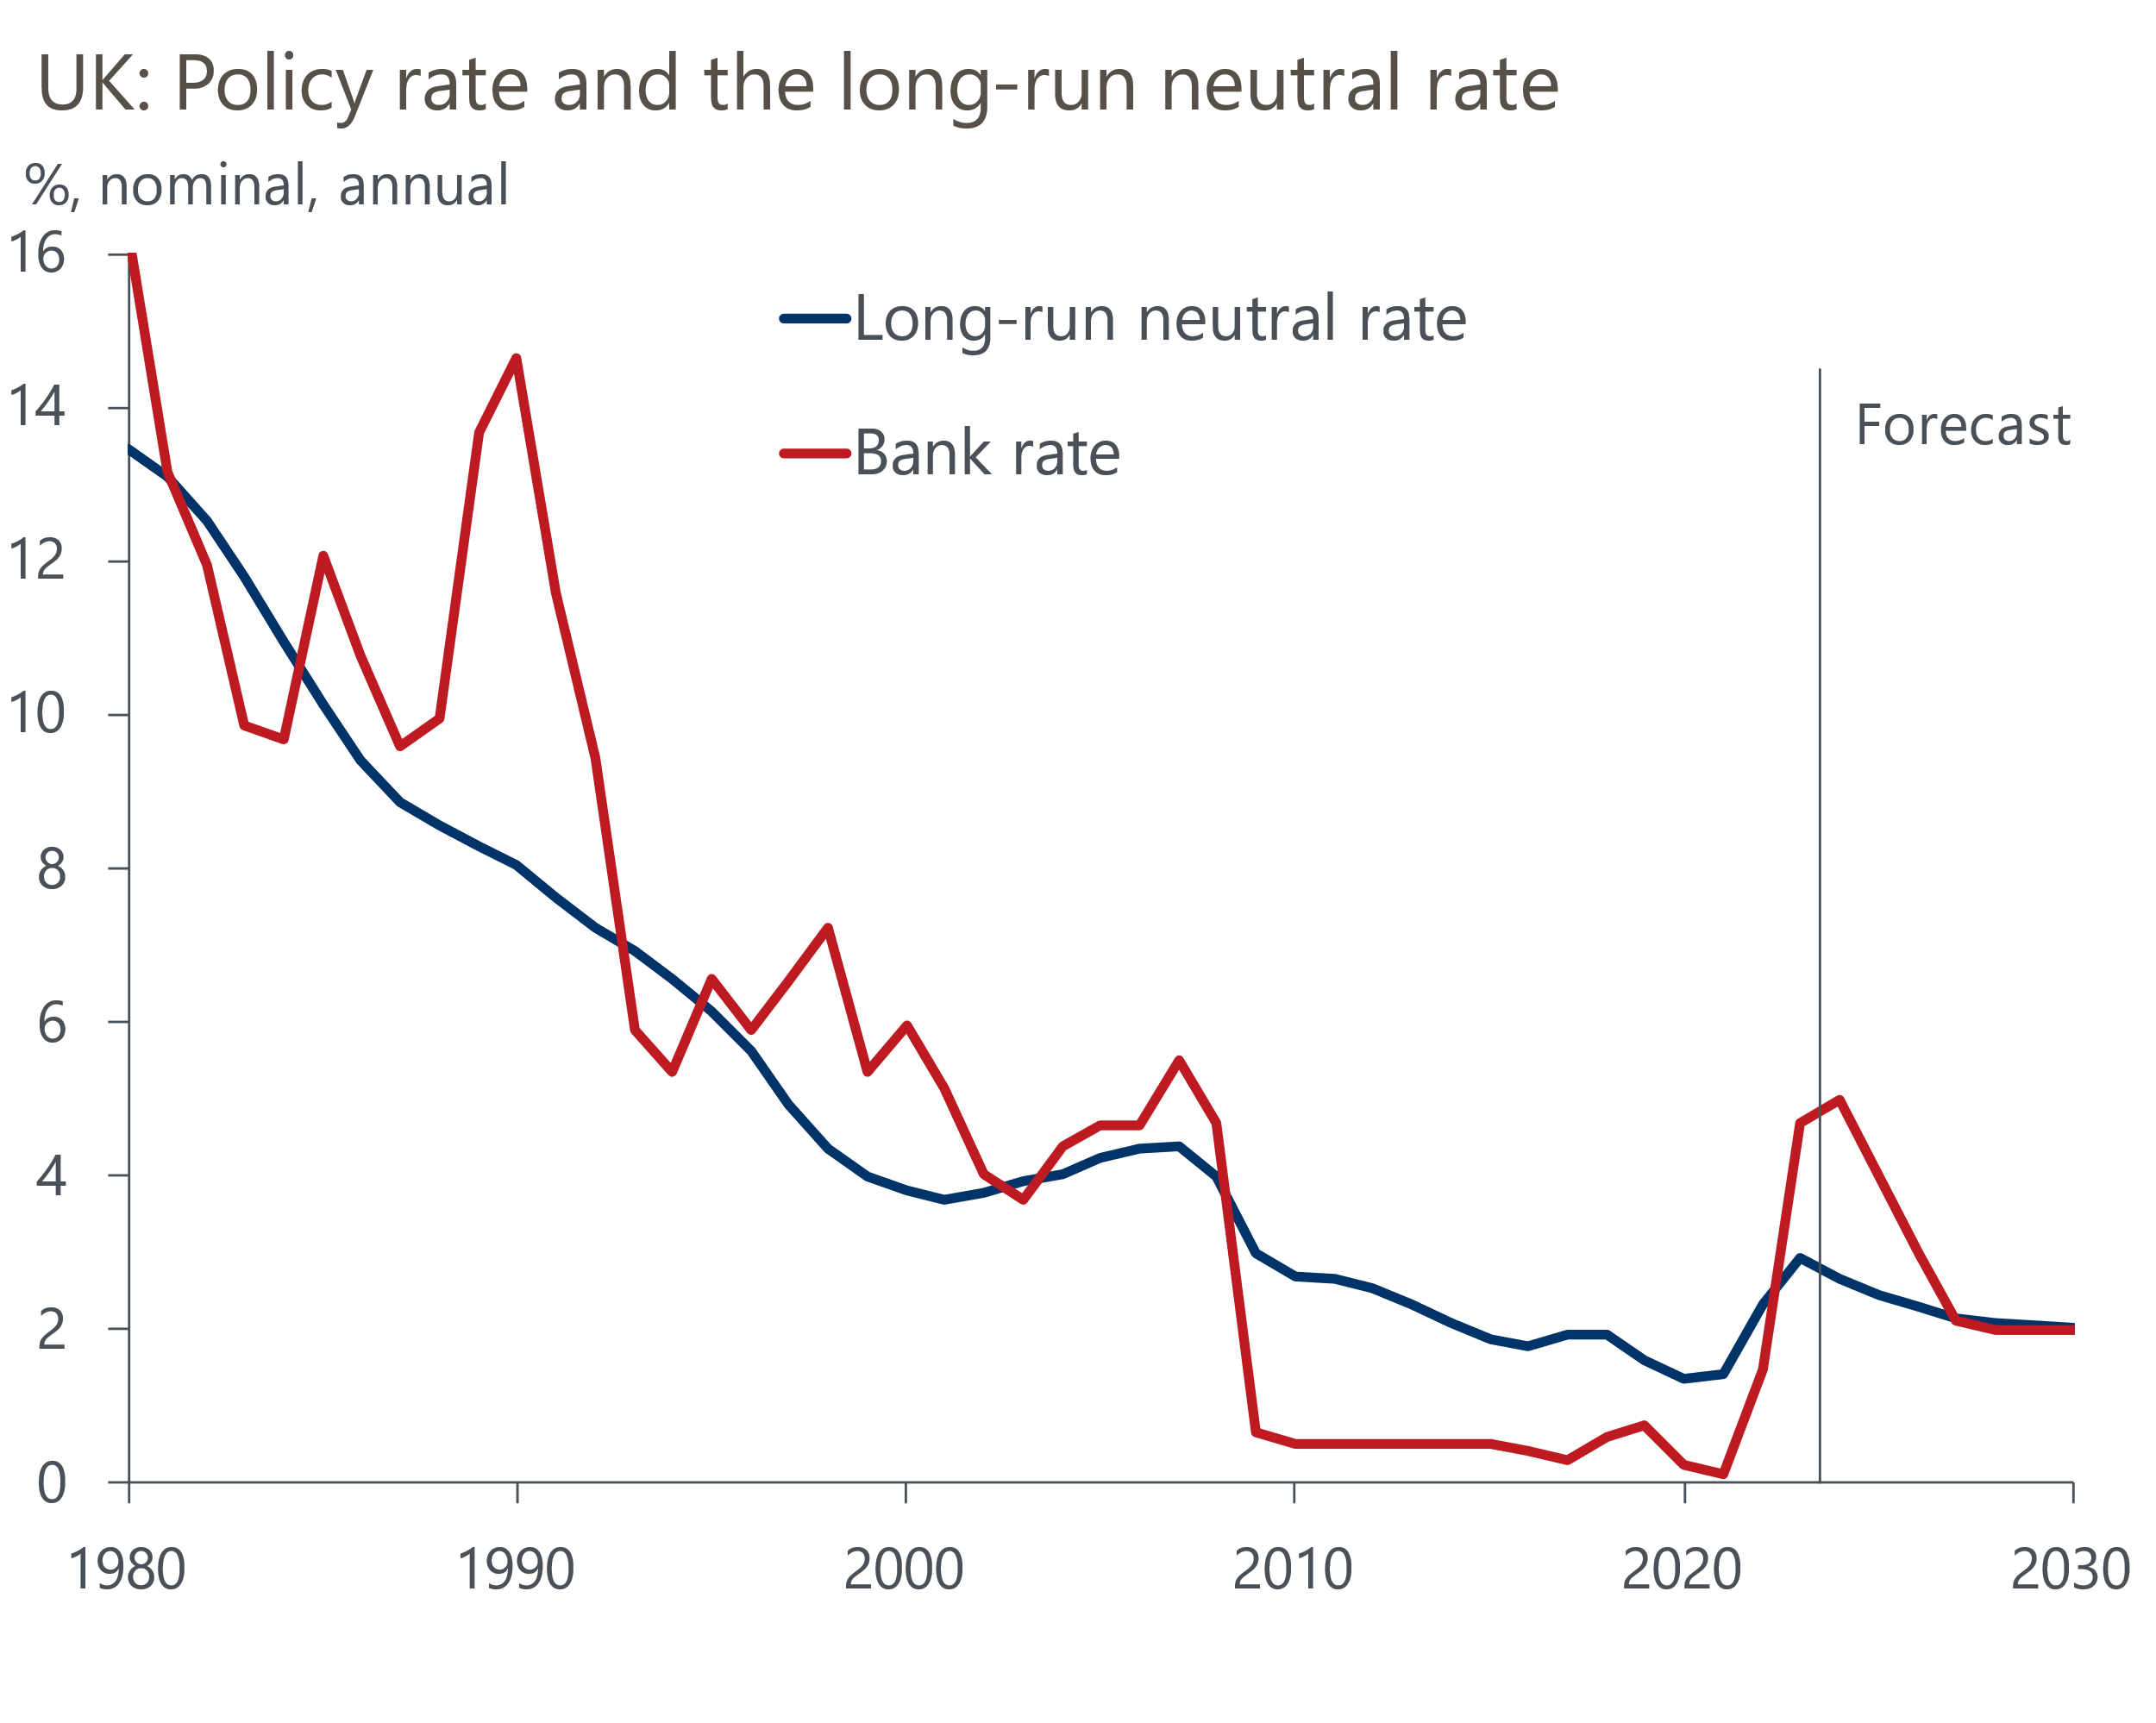
Source: Oxford Economics, Haver Analytics
While the neutral rate cannot be observed, so estimates are always subject to considerable uncertainty, we think our research provides a helpful framework to consider the factors shaping long-term interest rates. If Bank Rate were to be cut to the level that we estimate would represent a neutral policy stance in the long-term, this would have key implications for mortgage rates. Our findings imply that we're more likely to see mortgage rates remain above 3% over the next decade rather than the sub-2% deals many households benefited from in the second half of the 2010s, when policy settings had been very loose.

The week ahead
Another quiet week of economic data is in prospect, with May's final S&P Global surveys the only releases of note. The month's earlier flash survey reported a softer composite PMI, but the reading was still consistent with GDP continuing to grow at a solid pace in Q2. Meanwhile, the improvement in May's flash manufacturing PMI suggests the recovery is becoming more broad-based. We see little reason to think May's final PMI readings will shift from the outturns in the flash survey.
Table 1: Week ahead calendar
Date | Events | Period | Measure | Unit | Previous | Forecast
Jun 3 | S&P Global/CIPS manufacturing | May | PMI | % bal | 51.3 | 51.3
Jun 5 | S&P Global/CIPS services | May | PMI | % bal | 52.9 | 52.9
Jun 5 | S&P Global/CIPS composite | May | PMI | % bal | 52.8 | 52.8
Jun 6 | S&P Global/CIPS construction | May | PMI | % bal | 53.0 | 52.7
Jun 7 | Halifax house prices | May | m/m | % | 0.1 | 0.2
Jun 7 | Halifax house prices | May | y/y | % | 1.1 | 1.2
Source: Oxford Economics

Key forecasts
Table 2: UK forecast overview
(Annual percentage changes unless specified)
 | 2022 | 2023 | 2024 | 2025 | 2026 | 2027
GDP | 4.3 | 0.1 | 0.9 | 2.0 | 1.9 | 1.6
Private consumption | 4.8 | 0.2 | 0.7 | 2.6 | 2.2 | 1.6
Fixed investment | 8.0 | 2.2 | -0.5 | 0.8 | 2.7 | 2.1
Government consumption | 2.3 | 0.5 | 3.4 | 2.8 | 1.6 | 1.5
Exports of goods and services | 9.0 | -0.5 | -0.9 | 2.7 | 2.3 | 1.7
Imports of goods and services | 14.6 | -1.5 | 0.2 | 4.7 | 2.9 | 1.9
Industrial Production | -3.5 | -0.4 | 0.3 | 0.9 | 1.5 | 1.2
Consumer prices | 9.1 | 7.3 | 2.3 | 2.2 | 2.3 | 2.2
Unemployment rate (%) | 3.9 | 4.0 | 4.3 | 4.0 | 3.8 | 3.8
Current a/c balance (% of GDP) | -3.1 | -3.3 | -2.7 | -3.1 | -3.2 | -3.1
Government balance (% of GDP) | 4.4 | 5.0 | 3.6 | 3.1 | 2.3 | 1.5
Cen. bank policy rate (%, EOP) | 3.50 | 5.25 | 4.50 | 3.50 | 2.50 | 2.00
10yr govt. bond yield (%, EOP) | 3.67 | 3.54 | 3.92 | 3.53 | 3.07 | 2.85
Exchange rate (US$ per £, EOP) | 1.20 | 1.27 | 1.26 | 1.27 | 1.30 | 1.32
Exchange rate (euro per £, EOP) | 1.13 | 1.15 | 1.17 | 1.17 | 1.17 | 1.16
Source: Oxford Economics
Table 3: Quarterly forecasts for the UK
 | 2024 |  |  |  | 2025
 | Q1 | Q2 | Q3 | Q4 | Q1 | Q2 | Q3 | Q4
GDP (% year) | 0.2 | 0.5 | 1.0 | 1.9 | 1.7 | 2.0 | 2.1 | 2.2
CPI inflation (% year) | 3.5 | 1.9 | 1.8 | 2.1 | 2.0 | 2.0 | 2.3 | 2.3
Bank Rate (%, EOP) | 5.25 | 5.00 | 4.75 | 4.50 | 4.25 | 4.00 | 3.75 | 3.50
10yr gilt yield (%, EOP) | 3.95 | 4.10 | 3.99 | 3.92 | 3.83 | 3.74 | 3.64 | 3.53
US$ per £ (EOP) | 1.26 | 1.25 | 1.25 | 1.26 | 1.26 | 1.26 | 1.27 | 1.27
Euro per £ (EOP) | 1.17 | 1.17 | 1.17 | 1.17 | 1.17 | 1.17 | 1.17 | 1.17
Source: Oxford Economics

Latest Country Economic Forecast:
May 15, 2024

Recent publications

Data Insights
Costlier deals halted the recovery in mortgage approvals
Sharp fall in retail sales points to softer GDP growth in Q2
Composite PMI falls, but recovery still running at a solid pace
Inflation overshoot complicates matters for the BoE
A poor start to the new fiscal year

Research Briefings
Why the neutral interest rate will stay structurally low
Why the BoE can and will cut before the Fed
How quickly are indirect effects on core inflation fading?
Dovish MPC signals a summer rate cut is likely
MPC preview – Edging closer to rate cuts

Contacts

Oxford Economics' UK team
- Andrew Goodwin - Chief UK Economist - agoodwin@oxfordeconomics.com
- Edward Allenby - UK Economist - eallenby@oxfordeconomics.com

